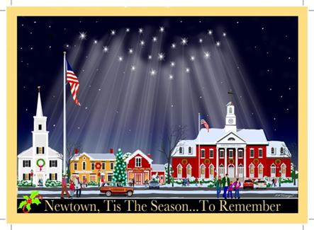
Newtown Action Alliance
Coordinated Strategy for 12.14.13
Objectives:
- Support Town Strategy – “Lead by Example: Perform Acts of Kindness”
- Deflect Media Attention to D.C.
- Promote National Call to Action

Tactics:
- December D.C. Trip “Lead by Example: Perform Acts of Kindness”
  - TBD-Tentative date: December 11, 12
  - Volunteer at shelters/soup kitchens/schools in DC
    - Invite Congress to participate
    - Collaborate with alliance partners, clergy, city council
    - Encourage people/alliance partners across America to do the same
    - Embed the media with us
  - Press conference/rally to kick it off
  - Deliver letters/slate list/holiday cards to Congress
  - Legislative meetings: TBD depending on availability of Congress
  - Culminating with a candlelight vigil (National cathedral?)

- Social Media Call to Action for 12/14:
“#RememberNewtown”
  - Change your hometown to Newtown on Facebook on 12/14
  - Change profile picture 12/14
    - Use “Newtown. Tis The Season… To Remember” image

- National Call to Action for Holiday Season:
  - Mail personalized holiday postcards to Congress in Washington D.C. (with minimal fee for processing/delivery)
    - Postcard image of Newtown’s Main Street during holidays w/light from 26 stars illuminating the flagpole & quintessential main street, just like Main Street USA
    - “Newtown. Tis The Season…….To Remember”
    - Message to congress: To be refined.
    - Start date: As soon as the platform is created & continue through New Year

***Success will depend on coordinated support from our alliance partners.

